Harry Potter Covers (Thinking about Target Audiences)

Harry Potter books were first published as children’s books. However, many adults started reading them and the publishers realised that even more would if they ‘disguised’ the front cover as an adult’s book.

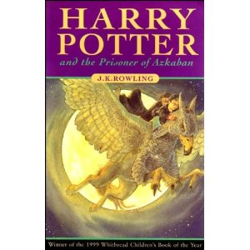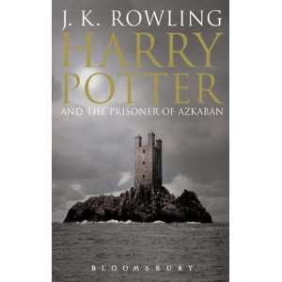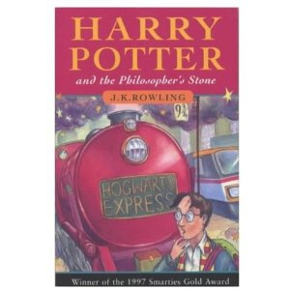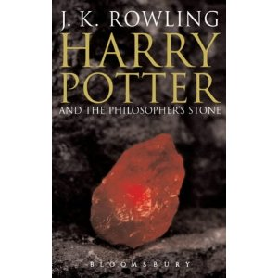

Questions: Which book covers are aimed at adults? Which book covers are aimed at children?

What are the main differences between the covers that are aimed at children and those that are aimed at adults? Why do you think these differences exist?

Each group will discuss one of the following features:
Group One: Image choice
Group Two: Mood/ atmosphere created
Group Three: Use of colour
Group Four: Positioning of the title and author’s name.
Group Five: Positioning and use of space
Group six: The way in which characters are presented (or not as is the case for two of the covers!)
Layout (positioning, use of space and size of objects)

Each of the following book covers has used a unique layout to inform the reader about the book. For each cover, try to explain how the layout has been used to give us information about the story within.

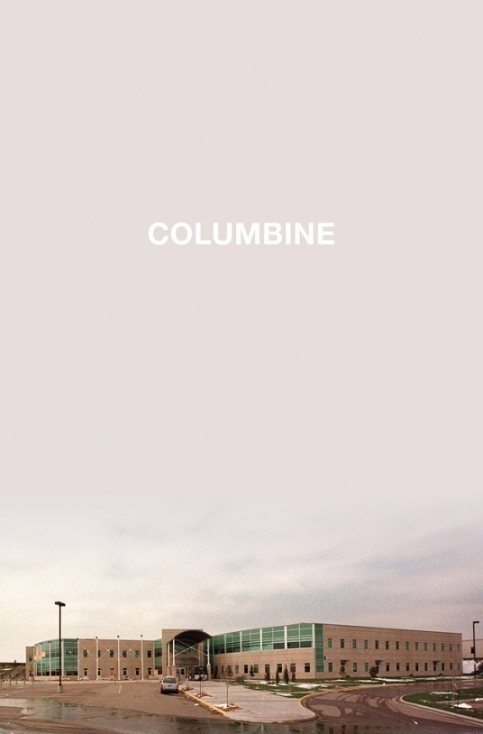
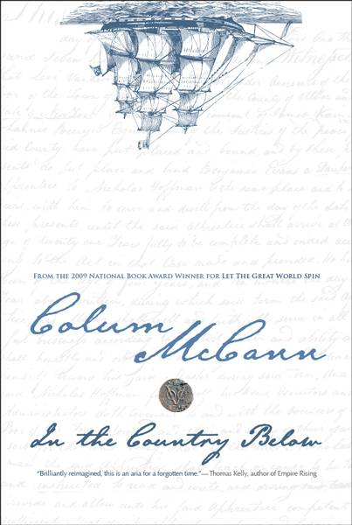
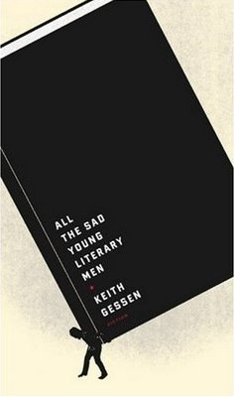
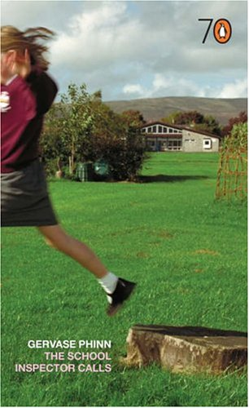

The technical term for an object that is half way out of a photo is ‘breaking the frame’. How does this influence the mood of the cover? What ideas about the plot does it does it add to the title?
Why is the book so large in comparison the person? This is a symbolic way of telling us about the plot. What do you learn about the story from the strange use of size?
Columbine is the true story of somebody who goes shoots people at a high school in America. How is the use of empty space and colour being used to create mood and atmosphere?
Why has the designer positioned the boat upside down? What does this teach you about the plot? Hint: Where is ‘the country below’?

Titles
The way in which the title on a book cover is written (the font, style, shape and/or position) can in some cases give us information about the book.
Look at the covers below and discuss how the titles contribute to our understanding of the book.

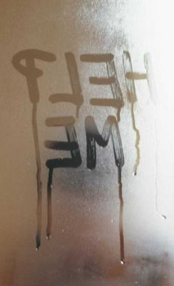
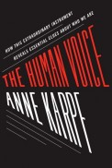
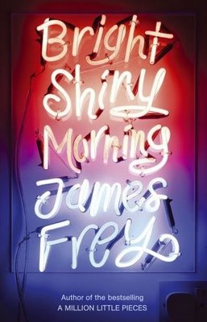
What does the choice of font for this title teach us about the novel’s plot and setting? Can we guess what style of writing is used by looking at the front cover?
Why do you think the title has been written on a fogged-up window? What ideas does this give you about the plot? What atmosphere does it create?
Look at the way in which the title has been positioned and shaped. Why do you think the designer has done this?
Think about the title of the book and then the fact that neon lights have been used to create the title. What is strange about this? What do you think it teaches us about plot and setting?

Symbolism on the front cover
The Twilight series of books uses very symbolic covers with simple but bold images and only a few contrasting colours. Try to guess what the symbols teach us about the plot and/ or themes.
The color white and flowers often symbolise purity or innocence. Imagine that the flower represents a character in the book.
1) What does the colour red symbolise?
2) Why is there red on the flower?
3) This is the only cover with green on it. What might this symbolise?

The game of chess involves a challenge between two people. Use this as a hint about the plot of the book.
1) What do you think happens to the main character in the book?
2) Why is one chess piece bigger than the other?
3) If you play chess try to explain to other group members why the pieces that are being used are important. What does this suggest might happen in the story?

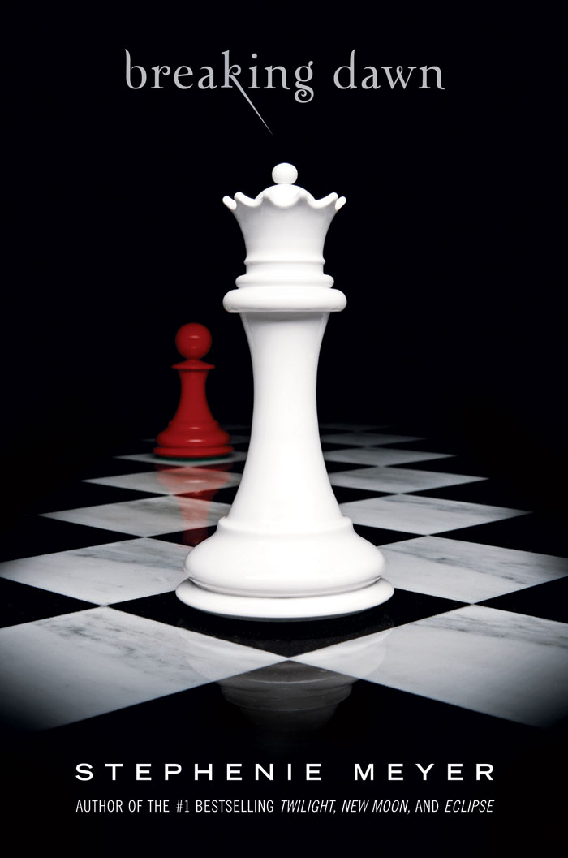
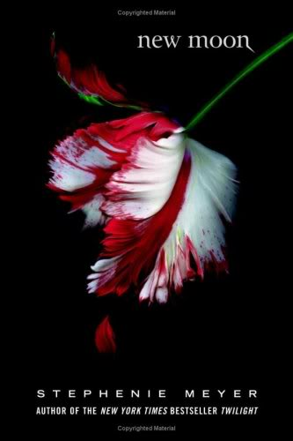

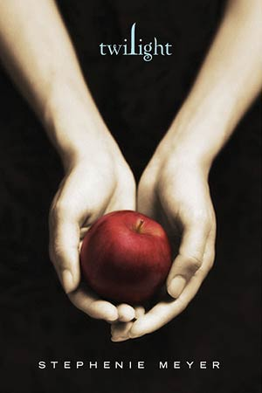
Hint: A ribbon is used to tie things together.
1) How are we tied to other people? What might this mean the ribbon represents?
2) Why is the ribbon being ripped rather than cut? What is the difference between ripping and cutting?
3) Why is the ribbon red?

An apple is used in many stories to tempt a character to do something bad or dangerous. (For example, Snow White is tempted with an apple.)
1) Why is the person holding an apple in her hands?
2) Why hasn’t she eaten the apple?
3) If you have read the book decide what the apple might represent.

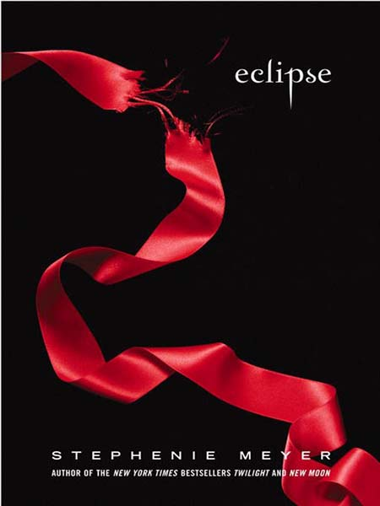

Discussion: Red, white and black are the main colours used on each of the covers. Why do you think the designer did this? What information does it give us about the plot, genre and the themes of the book?
http://hillmanm.ism-online.org/2010/08/25/mini-book-assignment-help-and-worksheets/

